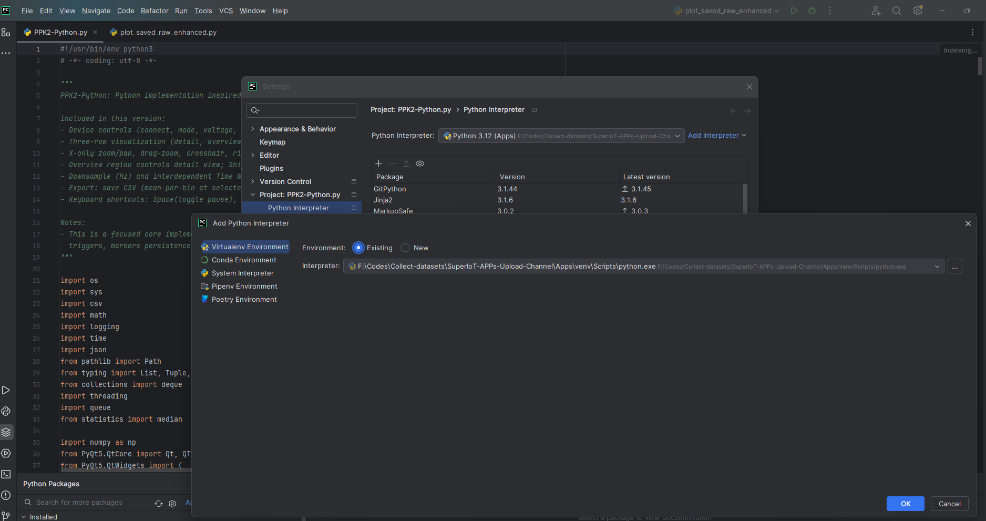

Interpreter Path:
XXXXX \SuperIoT-APPs-Upload-Channel\Apps\venv\Scripts\python.exe

Inside site-packages, run this in PowerShell:
ls *.dist-info | ForEach-Object {
$name = $_.Name -replace '\.dist-info',''
$split = $name -split '-'
$pkg = $split[0]
$ver = $split[1]
"$pkg==$ver"
}
Copy the output into requirements.txt.

- Delete the broken .venv
- Create a new one:
python -m venv .venv
- Activate it
- Install:
pip install -r requirements.txt

- Install provided firmware on Node and Mini Lamp provided by Senhui (flash using Arduino IDE, Board Adafruit nrf82833 for node and Seeed Arduino nRF52840 for gateway
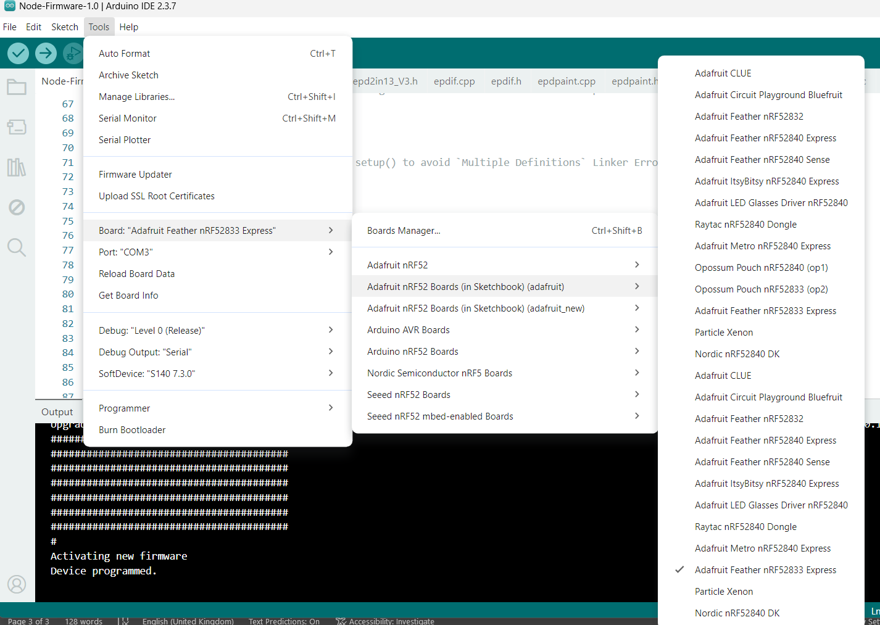
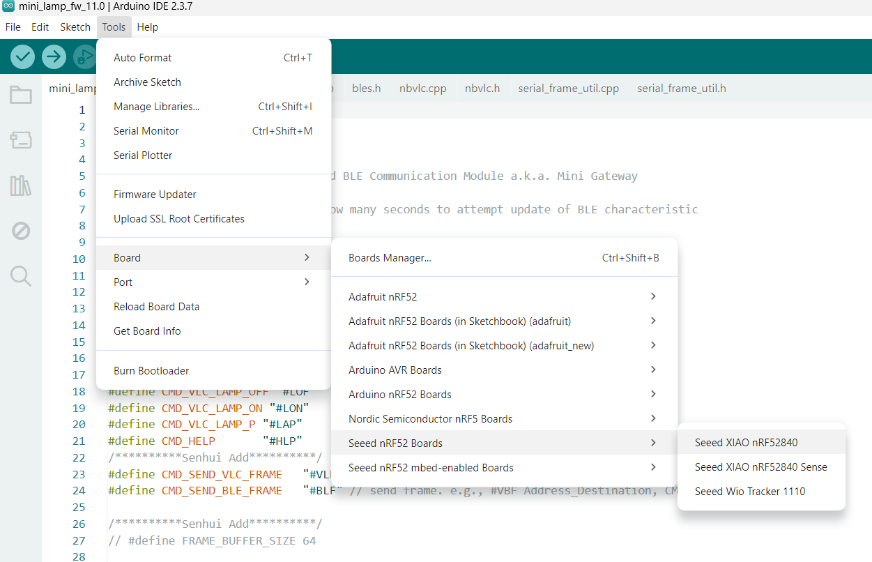
- Connect each node and each gateway to a PPK2 power profiler (using power and GND leads), and run USB cable from nodes and gateways to Hub (using Senhui cabling setup) – A common ground (GND) black cable is also connected to PPKIIs.
- Connect PPK2 power profilers to USB as well.
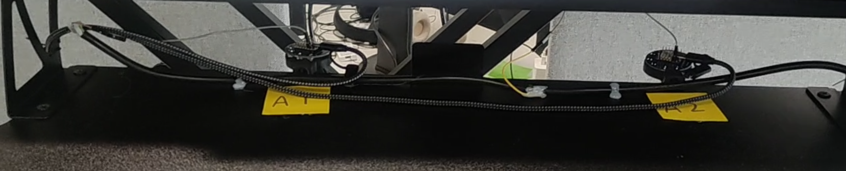
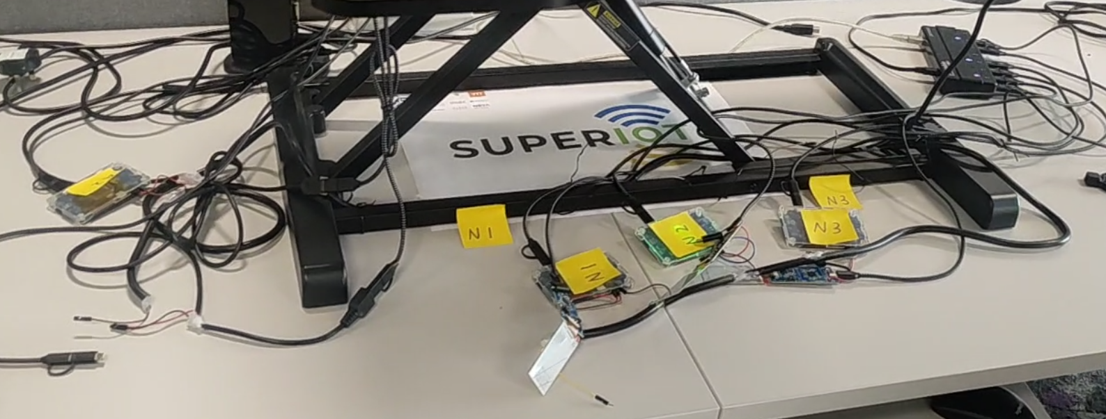

In VS code, open directory.
select interpreter (Ctrl+ Shift + P)
Python-select interpreter
+create virtual environment
Venv
Delete and Recreate
Python 3.11 C:\****
Select requirements.txt

TESTING FOR 1 NODE and 1 GATEWAY
Run python PPK2-Python.py in terminal (for node current measurements). Following window will appear.
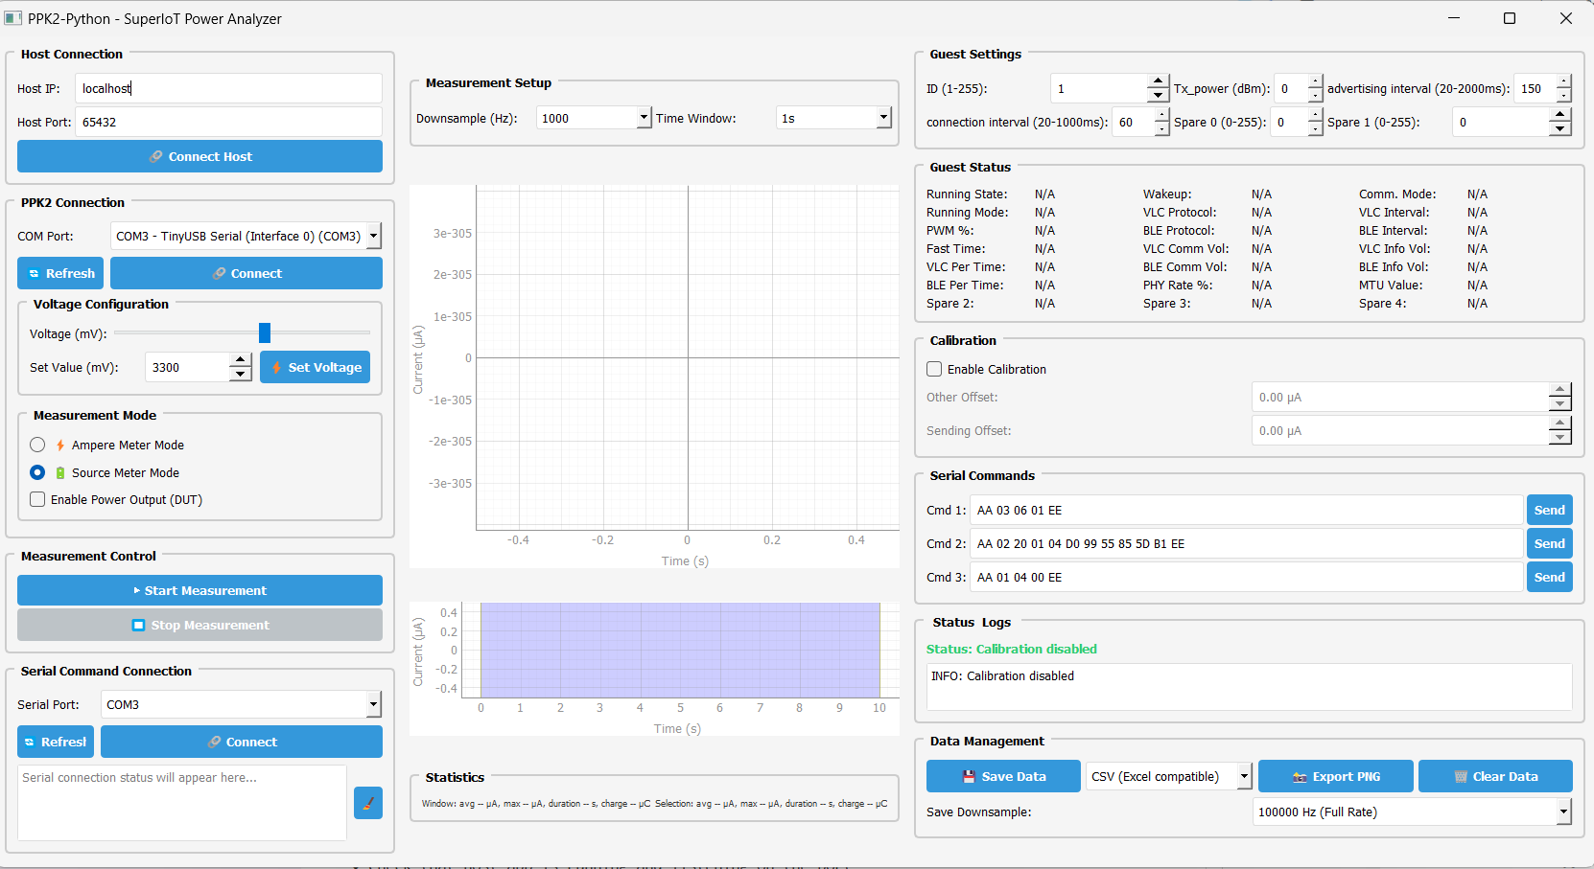

Suggestion:
IDs in Guest Settings <10 for nodes, >10 for mini lamps (but user can define any IDs)

  - Click Refresh, Select COM Port in “PPKII Connection”) for PPKII power profiler connected to the node (e.g. COM5 – nRF Connect USB CDC ACM (COM5))
  - Click Connect
  - Set Voltage (3300 mV for NODE)
  - Source Meter Mode (Check “Enable Power Output (DUT)”)
  - Click Start Measurement
  - PPKII power profiler will turn RED
  - Need also to “Connect” serial port of node in “Serial Command Connection” (Refresh if needed, note this is different Com port than the PPK2 connection port). Note before you Connect you can set up parameters like Tx_power, advertising interval, connection interval etc. Also note that every time, you need to flash the firmware on the node and gateway if you want to change parameters in Guest settings.
  - Check the “Commands_node.txt” and “Commands_minilamp.txt” files for list of commands you can send from node to gateway (Commands_node.txt) or from gateway to node (Commands_minilamp.txt).
  - Save data

For recording the measurement on the mini lamp gateway, open another terminal, and run python PPK2-Python-Minilamp.py. The default ID is 10.
Note: For mini lamp set voltage to 5000 mV.

Note: If you send deep sleep command from gateway to node, the node power will be disconnected (but not the current measurement). Then press connect again on the Node App.
#####################################################################
- When you click save data (raw), it will be saved as several parts (better to save data for each node and gateway in separate folders)
- Run “plot_saved_raw_enhanced.py” to refine the data.
- The new generated files will have the “_refined” text appended to the filenames
- Preprocess data in different steps using scripts in “Predictor and Optimizer\Preprocess_dataset” folder

